Project: Food Safety Sudoku
Difficulty: Level 1

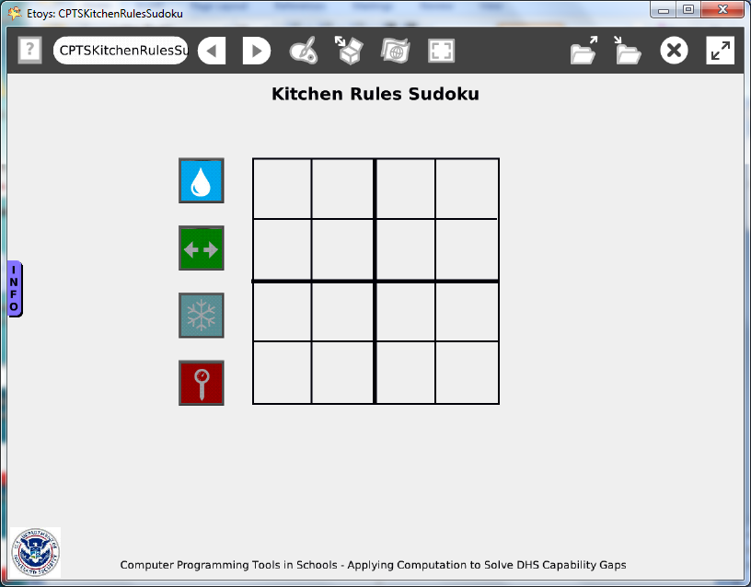

Time: Two 45 minute labs

Challenge:
Create a Sudoku puzzle that uses icons to represent good food handling and storage practices. The web site www.foodsafety.gov uses these icons and is a rich source of information about safe food handling practices.

Programming:
This project uses Etoys multi-media authoring tools such as writing text, importing digital images and the using paint tools.

Things you’ll need to know:
Quick Guides
- Paint Tools/ All
- Halo Handles/All
- Supplies: Object Catalog, Text, Add a New Flap, Playfield
- Object Catalog: Grab Patch, Digital Images, Maker Button
- Menus: Playfield Graph Paper

Things to think about:
- Are these practices followed at each stage in the food distribution network?
- Observe the application of these practices in shops, homes, and restaurants near you.
- Imagine how many hands have touched the food you ate a lunch today and estimate how many of them have followed these practices.

Extensions:
- Design a new set of icons to promote safe food handling practices in your community.

NETS for Students:
http://www.iste.org/standards/nets-for-students/nets-student-standards-2007.aspx
1. Creativity and Innovation: a, b
2. Communication and Collaboration: b
3. Research and Information Fluency: a, b
4. Critical Thinking, Problem Solving, and Decision Making: a, b
5. Digital Citizenship: a, b
6. Technology Operations and Concepts: a, b, d

CSTA:
CSTA Level II: Objectives and Outline
http://csta.acm.org/Curriculum/sub/CurrFiles/L2-Objectives-and-Outlines.pdf
Level II objectives for middle school students are furthered through studying a programming language well enough that the student is proficient with it. Whether the language is Etoys, StarLogo TNG, or Scratch, it is the ability to use the language to express ideas that is valuable. A student skillful enough to use any programming language to express ideas, solve problems, model behaviors, simulate data, or to educate or entertain is an entitled person in today’s society. Topics of particular note are:
Topic 2: Problem Solving
Topic 6: Connections between Mathematics and Computer Science
Topic 11: Programming Languages
Topic 13: Multimedia

Common Core Standards Mathematics:
http://www.corestandards.org/the-standards/mathematics
6. RP.3
8. SP.4

Teacher Notes:
Materials: Provide a print or screen image version of the icons from foodsafety.gov. Give the class time to research the topic in the web site.

Comments: The scripts are not difficult but the decisions take time and thought.

Objects - Scripts – Decisions
The puzzle grid is a sketch that was drawn over a playfield grid. The size of the squares can be selected in a menu for the playfield. After the grid was painted, the playfield was discarded.
The puzzle could use the grid in the playfield or the grid could be drawn free style to give students practice estimating divisions of the whole square.

Example Scripts: This project uses multimedia authoring tools; there are no scripts in this project.

Student Notes:
None provided for this project.

